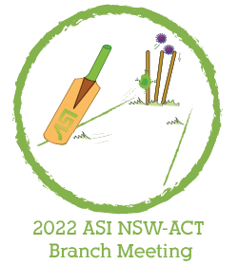

Abstract theme
(please tick all that applies)

Infectious Diseases

Cancer & Immunotherapy

Autoimmunity

Immunodeficiency

Inflammation

Cell Signalling

Single cell

Metabolism

B cell biology

T cell biology

Innate cell biology

Antigen presentation

Other: ____________

Career Stage (please tick all that applies)

Honour Student

Masters/PhD student

Post doc (<5 years post PhD)
Post doc (>5 years post PhD)

Lecturer/Senior Lecturer

Assoc. Prof/Professor

Other:____________

======================================================================

Abstract Title

Author 1, Author 2.. (Please underline the presenting author in the author list)
Affiliations
Corresponding author
Abstract text (max 250 words)

